BIOC 404 Dr. Silvius February 1, 2006
Author’s Note: Since this was a rather vague and rapid lecture and no recording exists, I am going to take the liberty of filling in the blanks using the course pack.

The Effect of Solvent Polarity on Absorbance
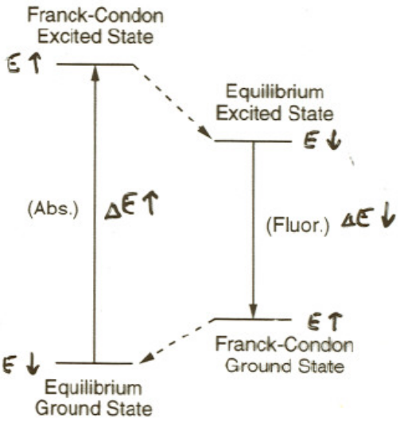
This topic is a continuation from last class.
The energy arrows (E↓) indicates the change in energy of a trp molecule when placed in a more polar solvent
There are two factors to consider when talking about the ‘polarity’ of a fluorescent molecule’s environment: the local dielectric constant, and the polarizability.

Fluorescent molecules exhibit a greater dipole moment when in the excited state than when in the ground state. Therefore, it is possible for the polarity of the solvent to affect the energies of the ground and excited state of the molecule, thus affecting the fluorescence spectrum of the molecule.

In a More Polar Solvent: The absorbance is blue-shifted, meaning that the molecule will show a higher energy of excitation. This is because there is a greater energetic ‘penalty’ when the solvent and sample molecules do not align properly in the Franck-Codon excited state.

In tryptophan, more increase in the polarity of the solvent/environment lowers the energy of the excited state dipole

Solvent polarity increases, leads to the absorption λ_{max} blue-shifts.

The fluorescence is red shifted, meaning that the molecule will show a lower energy of emission. This occurs because there is a greater energentic ‘payoff’ when the arrangement of the solvent and macromolecule becomes optimal in the equilibrium excited state.

Solvent polarity increases, leads to fluorescence emission λ_{max} red-shifts.

Application: Since tryptophan exhibits fluorescence, it is possible to monitor its local environment based on its excitation and emission spectrum. This spectrum can be compared to reference spectrum to determine the polarity of the Trp environment.
Trp¹
Trp⁵⁷
Trp on the surface, high local polarity (dielectic є )
Red-Shift

Trp buried inside, low local polarity
Blue-Shifted

Energy Dissipating Pathways

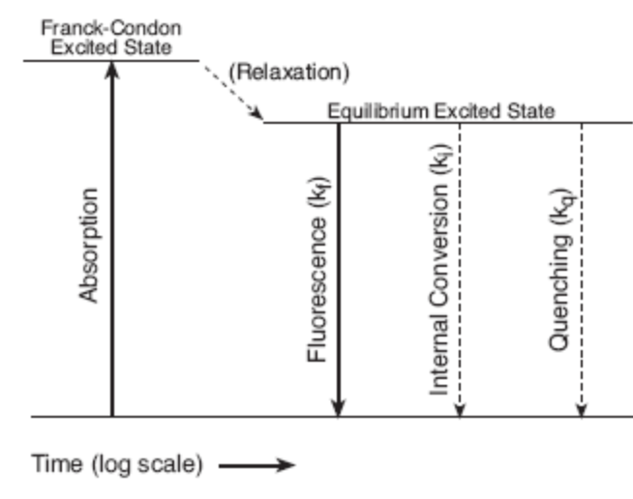
When a molecule picks up a proton and is excited, it has several ‘choices’ about how to get back to the ground state:
1)Emit a photon
2)’Internal Conversion’
( 3) Quenching)

Wavy or dashed arrow = radiation- less transmission
Internal conversion = ‘non-radioactive’ dumping of the excess electronic-state energy into molecular and solvent vibrational modes. This means the electron can return to ground state orbital.

Fluorescence Quantum Yield

Ф ≡ (number of photons emitted as fluorescence)/(number of photons absorbed)

Technically, this equation overlooks some factors, but is correct enough for us.

This equation represents the fraction of excited state molecules that fluoresce

Ф = k_{fl} / (k_{fl} + k_{ic} + (k_{other})) k = 1st order rate constant; fl= fluorescence; ic =internal conversion

Fluorescence Lifetime

Experiment: Flash-irradiate (psec-long laser pulse) a fluorescent sample and monitor the
intensity over time .
Fluorescence Lifetime
Fluorescence emitted
Time after pulse
I_{(t)} = I_{0⋅}exp(-t/τ_{FL})
I₀

Lifetime τ_{fl}= 1/(k_{fl} + k_{ic} +(k_{other}))

The lifetime is related to the quantum yield equation.

Why is monitoring lifetime useful?
-intrinsic property
-Not dependent on the number of molecules in the sample
-Not distorted by intensity
-Can differentiate the environment of the cell

Quenchers: The 3rd way of transitioning from the excited to ground state (k_{other} = k_{o} [Q] ) without fluorescence (i.e. without photon emission).

k_{o} = intrinsic constant; [Q] = concentration of quencher

Examples: I- (iodide) and acrylamide, which are both soluble and polar

Flourescence Quantum Yeild with quencher:
The quantum yield drops with quencher addition.
Ф = k_{fl} / (k_{fl} + k_{ic} + (k_{o} [Q]))

Lifetime with Quencher:
τ_{fl}= 1/(k_{fl} + k_{ic} +(k_{o} [Q]))

Lifetime drops as the concentration of quencher rises.

Application:
As far as amino acids go, only tryptophan and tyrosine fluorescence. We like to use tryptophan because it fluoresces at an order of magnitude greater than tyrosine.
Trp
I-
Trp
I-
Trp buried in hydrophobic core

Low access of I-

Leads to weak quenching (Low k_{Q})
Trp on surface

High I- access

Leads to strong quenching (high k_{Q})

By using quenchers it is possible to distinguish between buried and exposed tryptophans.
It is also possible to engineer proteins (by adding Trp residues) in order to examine solvent accessibility of the surface of the protein.

It is possible to distinguish multiple Trp residues within a protein due to differences in their kQ values and the distinguishing curves produced. (A very good question from the audience).

Fluorescence Resonance Energy Transfer (FRET or RET)
This is another type of quenching.

Basic Requirements: -Fluorescent Donor (D)
-Fluorescent Acceptor (A)

Key Condition: The excitation spectrum of the acceptor species must significantly overlap with the emission spectrum of the donor species

Application:

D
A
Photon
λex (D)
Photon
λem (A)
Radiationless energy transfer
Fluorescence

The sample is exposed to light at the excitation wavelength of the donor species (λex).
If the acceptor species is close enough, the excess energy is siphoned off from the donor species in a radiationless energy transfer to the acceptor molecule. The acceptor species can then emit a photon at a different wavelength (λem), giving off fluorescence.

FRET Efficiency (є) Depends Upon:

1) Donor acceptor spectral overlap
It is important to note that this property is not a spatial property, but is fixed by the choice of donor and acceptor molecules.

2) Relative Distance (R) of the particular donor and acceptor molecules
This is a spatial quality and can vary. (This is also the quality we will focus upon).

3) Relative Orientation of the particular donor/acceptor pairs
Usually we assume that the molecules are randomly oriented except in highly ordered or rigid systems. This assumes that all these orientations average out.

Two Ways to Measure є
First, two samples must be analyzed. One sample contains only D and the other a similar sample containing D and A. Then there are two ways to measure the efficiency.

1.) Measure the fluorescence of the acceptor molecule.
2) Measure the quenching of the donor fluorescence.

The lifetime and intensity of the donor species lessens with the addition of acceptor molecule

Then use the equation:

є(FRET) = (Fl(λem (D) (D only)) - Fl(λem (D) (D+A))) / Fl (λem (D) (D only))

In verbal terms, subtract the fluorescence emitted from the D in the sample with donor and acceptor from the fluorescence emitted from D in the sample which only contained donor. Then divide this difference by the fluorescence emitted in the donor only sample to get the efficiency.

Note: Some donors can fluoresce before the acceptor ‘robs’ them of their energy.
If efficiency is 100%, then all the fluorescence is from the acceptor.

The efficiency equals zero if there is no FRET (i.e. if the fluorescence of the donor is the same with and without the addition of acceptor).

The efficiency equals one, if FRET is 100% efficient (i.e. every time a donor molecule is excited, it transfers its energy to an acceptor, which fluoresces).

Likewise: є (FRET) = ((τ_{fl} (D) (D only)) - (τ_{fl} (D) (D + A))) / (τ_{fl} (D) (D only))

Remember:
Lifetime τ_{fl}= 1/(k_{fl} + k_{ic} +(k_{other}))

If you are curious about how to measure efficiency using the measurement of acceptor molecule fluorescence, see below. If not, take comfort in that fact that it was never gone over in class and skip it.

Q: Is it possible to determine the efficiency of energy transfer
by monitoring acceptor fluorescence? If so, what comparisons need to be made
(measurements taken) and what form would the equation take?

A: You can do it, but it's a fair bit harder. You can for example construct a model compound
(e.g., a short flexible linear molecule that can be labeled at both ends) that is labeled
with the donor and the acceptor species and in which the distance between the donor and
acceptor sites is << Ro, so that the FRET efficiency is essentially. You then prepare
two samples, one containing this model compound and the second containing your biological
sample of interest, matching the concentrations of the donor species in the two samples.
Now determine the intensity of fluorescence of the model-compound sample and of the
biological sample when you excite each at the donor excitation wavelength and measure
fluorescence at the acceptor emission wavelength; call the resulting values Fl(model) and
Fl(biological). The FRET efficiency will then be epsilon = 100% x (F(biological)/F(model).

In practice, almost no one does this. Instead, people typically measure the acceptor
fluorescence (when exciting at the donor excitation wavelength) under varying conditions
and compare ratios of the fluorescence measured under two (or more) different conditions;
this is equal to the ratio of the FRET efficiencies under the two conditions. If for
example you see an x-fold increase in FRET from CFP-ras to YFP-RBD (RBD = activated
ras-specific binding domain from Raf) after treating cells with some extracellular
ligand, you can conclude that there has been an approximately x-fold increase in the
extent of activation of ras upon treatment with the ligand

Take care,

JRS

Efficiency (є) Depends Strongly on Donor-Acceptor Distance (R)
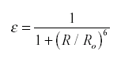
R_{o} = Förster radius
-A fixed property of our D-A pair

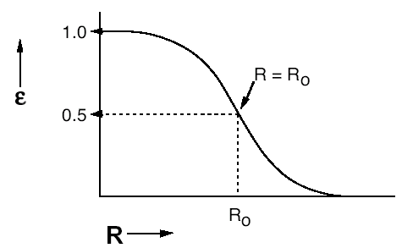
0.25
As you can see, at 0.25 R_{o} is close to maximum efficiency.

Application: Fluorescence Assay

D
A
CFP
YFP
Caspase site
A
D
FRET
NO FRET
Caspase Activation
<<60Ǻ
100 Ǻ or more
є→ 0
Donor and acceptor molecules have to be within a certain distance to fluoresce. We can use this requirement to our benefit. In the example to the left, donor molecule is a cyan fluorescent protein (CFP) and the acceptor is a yellow fluorescent protein (YFP). This donor acceptor pair is connected by a caspase cleavage site. Thus by monitoring the efficiency of the FRET we can examine the activity of the caspase that would cleave this site.
Special thanks to Jean-Philippe, whose fluorescence lifetime graph and figure seen above were modified for this NTC.

